10 Tips for Creating Accessible Course Content

Webinar Objectives for April 30, 2020
- Explore different ways to make your course more accessible.
- Complete a series of action items to promote accessibility in your course.
- Locate resources on CELT’s Accessibility in Your Course webpage (http://bit.ly/celt-access).

Tip 1: Plan your online teaching-learning strategy
Online course design should follow a consistent structure throughout the entirety of the course. The image below outlines clear steps for students to navigate a course. For each module there is a lecture, a video, slides, assignments (online discussion and a task) and a quiz.
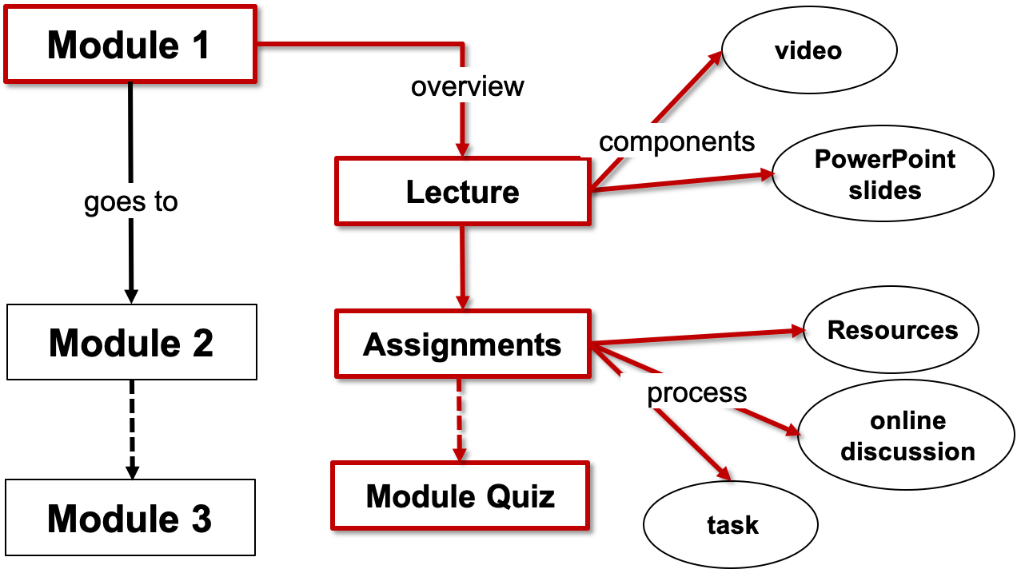
Image 1. A flowchart showing the process for students to follow for navigating the course.

Action Step: Sketch a flowchart for an existing or imaginary course module. If you’re stuck, create a module explaining how you get to where you are located from the closest entrance.

Tip 2: Provide adequate time
To be successful, students need time to complete activities and assessments. But how do you ensure that students have adequate time?
Action Step: Visit Rice University’s Course Workload Estimator webpage (https://cte.rice.edu/workload). Then, estimate the workload for the module you outlined in Tip 1.

Tip 3: Utilize both assessment and evaluation
Create assessment and evaluation tools that will allow you to determine if students have achieved a learning objective. Use a combination of assessment (not graded) and evaluation (graded) approaches provides students a variety of opportunities to show their mastery of the course content.

Tip 4: Use consistent page titles and headings
For users who rely on screen readers to interact with content, this step is crucial. Consistent and clear page Headings (H1, H2, H3, H4, etc.) help to orient visually impaired users who are unable to see the full layout of the site or a document.
Action Step: Watch Portland Community College’s Why Use Headings YouTube video (https://youtu.be/Q7hTVxmZ6UE). Then, respond to this question: What is the most important thing I learned from this video?

Tip 5: Use alt-text, captions, or long descriptions on all images
Every image must have alt-text, which can be set in the code for the image. This alt-text should be a concise description of the information conveyed by the image.
Action Step: Take a moment to write an alt-text description for the image below (note: for the sake of this exercise the image is marked as decorative).

Tip 6: Carefully consider color choices
Ensure color is not the sole means of conveying important information. The examples below show the differences between not accessible and accessible color-coding. Which is more accessible?
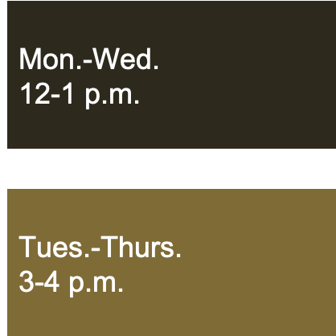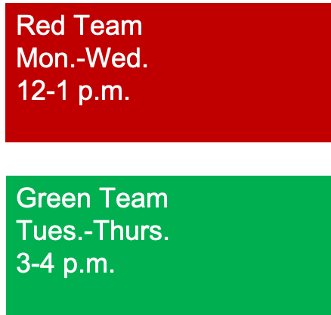

Tip 7: Use descriptive and unique hyperlinks
Another strategy to help users who use screen readers is when providing a hyperlink, the link text should describe what it is being linked to.

Accessible examples
- For a website or email newsletter: For information about creating an accessible course, visit CELT’s Accessibility in Your Course webpage.
- For a printed material: For information about creating an accessible course, visit CELT’s Accessibility in Your Course webpage (http://bit.ly/celt-access).

Not Accessible examples
- For information about creating an accessible course click here.
- For information about creating an accessible course https://www.celt.iastate.edu/teaching/effective-teaching-practices/accessify-your-course/

Tip 8: Include the accessibility statement in the syllabus
Include the university’s syllabus statement on accessibility. Consider placing the information towards the start of your syllabus to emphasize the importance of the information.
Action Step: Locate ISU’s Accessibility Statement on the Recommended ISU Syllabus Statements page (http://bit.ly/isu-syll). Include the statement in your syllabi. What additional ways can you promote accessibility in your course?

Tip 9: Create accessible media
If you choose to use or create multimedia for your course – remember the following accessible formats to be provided:
Audio only
- Text Transcript (of spoken word)
Video only
- Video Description (of key visual elements)
Audio and Video
- Closed Captions
- Text Transcript
- Video Description (of key visual elements)
For other course materials: PDF files, MS Word documents and PowerPoint are all popular tools used when presenting information to students. These files need to in an accessible format, or content must be provided to students in an alternative format.
Action Step: Explore CELT’s Video Creation page for captioning information and more (http://bit.ly/celt-vid) Then, use the built-in accessibility checkers on your course materials. If you need to learn how, use these resources:
- Use ISU Extension’s eAccessibility Initiative site (http://bit.ly/isu-eaccess)
- Make your Microsoft content accessible to everyone page (http://bit.ly/mso-access)

Tip 10: Build in course feedback
You can learn a great deal about how your students are learning in a course, and what adjustments both you and your students might make, by asking your students to give your course a mid-term evaluation. One way to do this is by using a PLUS/DELTA feedback tool (http://bit.ly/isu-plusdelta).
Plus
- What is helping me to learn in this class?
- What am I doing to improve my learning in the course?
Delta
- What changes are needed in this course to improve learning?
- What do I need to do to improve my learning in this course?
Action Step: Determine if you would use the Plus/Delta in your course.

Next Steps: What one thing will you use today? What is still left unanswered?
“10 Tips for Creating Accessible Course Content” by Center for Excellence in Learning and Teaching (CELT), Iowa State University is licensed under a Creative Commons Attribution-NonCommercialShareAlike 4.0 International License https://creativecommons.org/licenses/by-nc-sa/4.0/

